SHOW TITLE;________________________________________________________
DATE:___________________ TIME;____________
HOST:______________________
CO-HOST:_________________________________________
LOCATION:_____________________________
SET UP TIME:_______________________ END TIME:_____________________
TEAR DOWN:___________________________
POSTER:_______________ PROOFED:_____________ APPROVAL:_____________
SHARE POSTER ON FACEBOOK:YES/NO CREATE GROUP CHAT: YES/NO
CREATE FACEBOOK EVENT: YES/NO
EMCEE:_________________________________
PERFORMERS:
1.______________________________________________________, NUMBERS_____, MUSIC TURNED IN: Y/N
2.______________________________________________________, NUMBERS_____, MUSIC TURNED IN: Y/N
3.______________________________________________________, NUMBERS_____, MUSIC TURNED IN: Y/N
4.______________________________________________________, NUMBERS_____, MUSIC TURNED IN: Y/N
5.______________________________________________________, NUMBERS_____, MUSIC TURNED IN: Y/N
6.______________________________________________________, NUMBERS_____, MUSIC TURNED IN: Y/N
7.______________________________________________________, NUMBERS_____, MUSIC TURNED IN: Y/N
8.______________________________________________________, NUMBERS_____, MUSIC TURNED IN: Y/N
9.______________________________________________________, NUMBERS_____, MUSIC TURNED IN: Y/N
10._____________________________________________________, NUMBERS_____, MUSIC TURNED IN: Y/N
11._____________________________________________________, NUMBERS_____, MUSIC TURNED IN: Y/N
12._____________________________________________________, NUMBERS_____, MUSIC TURNED IN: Y/N
13._____________________________________________________, NUMBERS_____, MUSIC TURNED IN: Y/N
14._____________________________________________________, NUMBERS_____, MUSIC TURNED IN: Y/N
15._____________________________________________________, NUMBERS_____, MUSIC TURNED IN: Y/N

RAFFLE BASKETS: YES/NO (IF ICON EVENT –NOTIFY TREASURER) NOTIFIED: YES/ N/A
TICKETS: YES/NO BAGS: YES/NO TUMBLER: YES/NO RAFFLE SELLER(S):________________________________
BASKET DONATIONS:
1.________________________ 2.________________________ 3.________________________
4._______________________ 5.________________________ 6.________________________
SET DESIGN:
BACK DROP:________________________ PIPE AND DRAPES___________________________
LIGHTING:___________________________________________________________________________________
____________________________________________________________________________________________
SPOT LIGHT: YES/NO OPERATOR: _______________________________________
MUSIC: MIXER SPEAKERS, CORDS, STANDS, COMPUTER, THUMB DRIVE
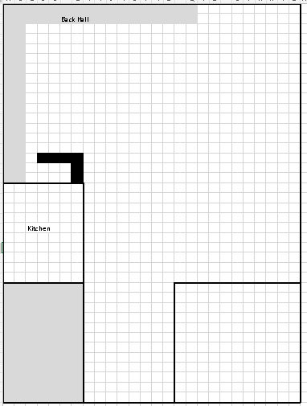
TABLE CLOTHES: YES/NO CENTER PIECES: YES/NO

